How to use the Comment Balloons in the Syllabus Templates
The first “screen shot” shown below represents the first page of the Syllabus Template for Phil 180. The pink comment boxes will probably display when you open the document, but if they don’t just go to “View” on the top toolbar and click the “Markup” option found toward the bottom of the list. A new toolbar will appear and on its left side you’ll see a white box containing either “Final Showing Markup,” “Final,” “Original,” or “Original Showing Markup” [designated as “(1)” on the second screen shot shown at the bottom of this page]. Choose the first of these four options. If you still don’t see the pink boxes click on the adjacent “Show” command and tick the Comment box that comes up. Once you have modified the template and are ready to distribute it to your students, you should permanently delete all the comments. So click on the little yellow icon with the red “X” in the middle, as designated by “(2)” on the second screenshot. When you do so, you’ll see “Delete all comments in document” as one of the options. Ta da!

First screen shot, showing first page of the Phil 180 template:
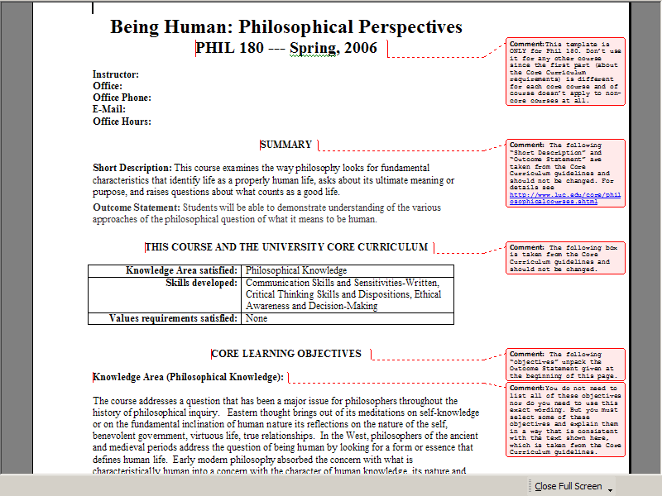

Second screen shot, showing how to display and remove comments:
