PROJECT DESCRIPTION:

STATUS (Healthy to Unhealthy - Green Lime Yellow Orange Red)
 | Prior | Current | Remarks

ASSUMPTIONS:

HIGHLIGHTS SINCE LAST STATUS REPORT:

SIGNIFICANT EVENTS PLANNED FOR THE NEXT 14 DAYS:

KEY DATES: Green Lime Yellow Orange Red
ACTION ITEMS/TASKS | OWNER | RESOURCES NEEDED/ DURATION | DATE | STATUS | COMPLETION DATE

PROJECT PLAN:

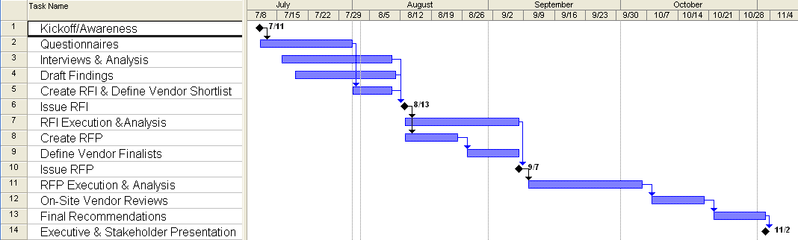

ISSUES: Green Lime Yellow Orange Red
NBR  OWNER | ISSUE  RISK | ACTION  STATUS  (Green, Lime, Yellow, Orange, Red) | AWARENESS  TARGET COMPLETION
1 | Issue | Action | Date
Owner | Risk | Status | Date

2

3

Project Team Members:
Project Sponsor
ITS Sponsor
Project Manager

